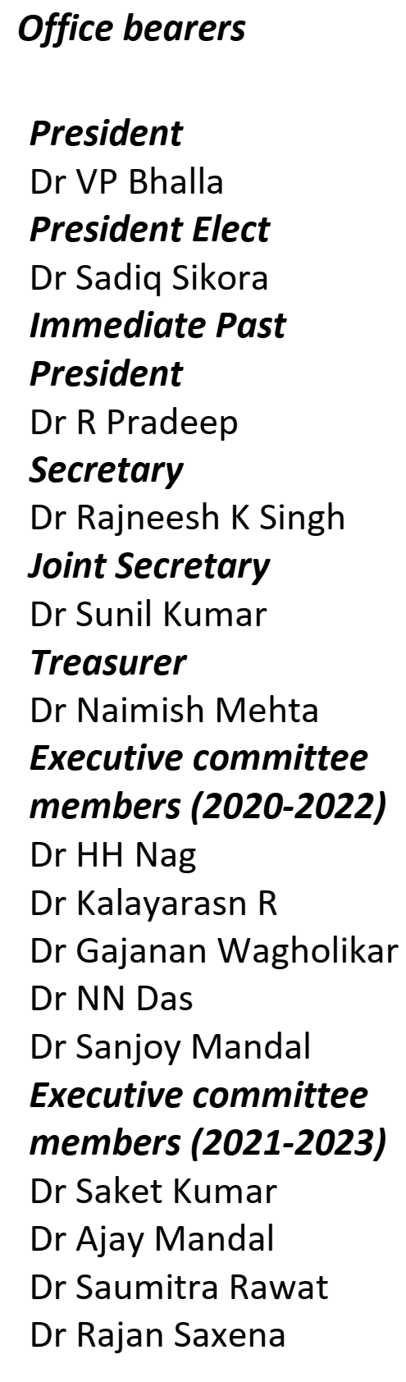

|  |
| --- |
| **Nominations are invited for the following office bearers – IASG** *(Only Full time Life members can apply, propose and second)* 1. One Post of President-Elect (2022-2023) 2. Five Members Executive Committee (2022-2024) |

**------------------------------------------------------------------------------------------**

**NOMINATION for**

* **President – Elect** (one post) **- *(tick mark to select)***
* **Member Executive Committee (2022-2024)** (five Posts) **- *(tick mark to select)***

**----------------------------------------------------------------------------------------------------------------**

**Person Nominated :**

Name :…………………………………………………………………………..  
Address :……………………………………………………………………….

……………………………………………………………………………………..  
ASI Membership No: ……………………………………………………..  
IASG Membership No:……………………………………………………  
E-Mail : ………………………………………………………………………… Contact phone no…………………….

Signature: ……………………………………………………………………. Date:………………………………….……

**Person proposing :**

Name :…………………………………………………………………………..  
Address :……………………………………………………………………….

……………………………………………………………………………………..  
ASI Membership No: ……………………………………………………..  
IASG Membership No:……………………………………………………  
E-Mail : ………………………………………………………………………… Contact phone no…………………….

Signature: ……………………………………………………………………. Date:………………………………….……

**Person seconding :**

Name :…………………………………………………………………………..  
Address :……………………………………………………………………….

……………………………………………………………………………………..  
ASI Membership No: ……………………………………………………..  
IASG Membership No:……………………………………………………  
E-Mail : ………………………………………………………………………… Contact phone no…………………….

Signature: ……………………………………………………………………. Date:………………………………….……



Contribution to Association as an official:  
(Not more than 100 words)

Contribution to Association as aa member:  
(Not more than 100 words)

Contribution to the Speciality:  
(Not more than 100 words)